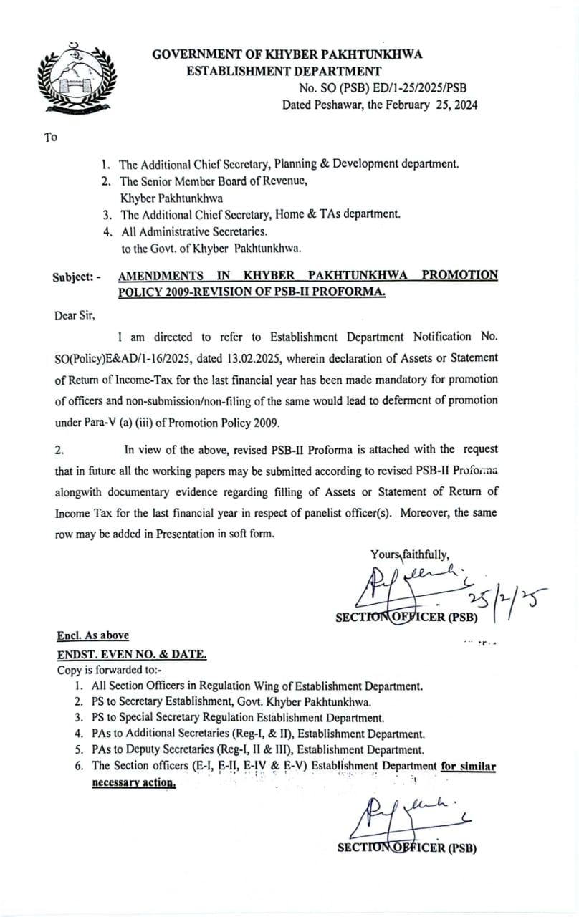

|  |  |  |  |  |  |  |  |  |  |  |  |  |  |  |  |  |
| --- | --- | --- | --- | --- | --- | --- | --- | --- | --- | --- | --- | --- | --- | --- | --- | --- |
| **PSB-II**  **PANEL OF OFFICERS FOR CONSIDERATION** | | | | | | | | | | | | | | | | |
| S. No | Seniority No. | Name of Officer with qualification | Date of Birth | Date of 1st entry into Govt Service | Date of Appointment /Promotion to BS-17 | Date of regular appointment/promotion to the present scale | Whether fulfill the prescribed length of service | Quantified scores | Missing PERs  (if any) | Disciplinary proceeding  (if any) | Case (if any) in any court of Law including NAB/plea bargaining with NAB | Mandatory training for promotion | Research papers | Assets / Income Tax Returns for the last Fin: Year | Present posting | Remarks |
|  |  |  |  |  |  |  |  |  |  |  |  |  |  |  |  |  |
| 1 |  |  |  |  |  |  |  |  |  |  |  |  |  |  |  |  |
| 2 |  |  |  |  |  |  |  |  |  |  |  |  |  |  |  |  |

**It is certified that: -**

* + 1. The officer(s) at Sr. No. ________ of the final seniority list have been promoted / retired / died / resigned. Documentary proof at F/ ________.
    2. The officer(s) included in the panel are eligible for promotion in all respects except at Sr. __________ due to missing PERs / pending inquiry(ies) / long leave / mandatory training etc.
    3. PERs of the panelist(s) are completed except at Sr. No. _________. The same has been conveyed to the panelist(s) well in time vide letter at F/_______.
    4. No inquiry / NAB case is pending against the panelist(s) except at Sr. No. ___________. Documentary proof is attached at F/ _______.
    5. The officer(s) / panelist(s) have submitted their Assets or Income Tax Returns for the last financial year except at Sr. No. ____. Documentary proof in r/o each officer is at F/ _______.
    6. No panelist(s) is on leave / deputation (within or outside the country) except at Sr. No. _______. Documentary proof is attached at F/ _______.
    7. No panelist(s) who left the department, resigned from service, died or retired from service is/are included in the panel.
    8. Nomenclature of the post(s) reflected in the budget book is / are at par with the relevant Service Rules of the Cadre(s).
    9. All the information given in the working paper / presentation are correct and in case, any concealment of facts arises later on, the administrative department shall be responsible.

**Signature _____________________________________**

**Designation ____________________________________**

**Date _____________________________________**